Module 8, Portfolio Milestone Option #1:

Data Analysis of United States Data

Tina Trainor
Colorado State University Global
MIS540: Introduction to Business Intelligence
Dr. Babi
May 29, 2021

Data Analysis of United States Data
Many business problems utilize large data sets to do descriptive, predictive, and diagnostic analytics. Learning information from our data to help predict future behavior is a valuable tool. Can data be shown to have predictive value by analyzing the data? This project will analyze a large data set to see if the data can be predictive and if there is value in making the predictions.
Project Overview
Problem
The country’s population is always shifting and the impact of the changes in population can affect funding for schools, health programs, housing projects and more. Each year changes in population are monitored to observe changes that might impact funding issues controlled by the apportionment of a state within the country. Can the US Census Apportionment dataset be used to determine when a state’s apportionment is likely to change? This information would be highly useful for a state to help budget for growth in a more efficient manner. Any advantage that a state could have to predict its citizen’s needs would be helpful. Can the last century of US Census Apportionment dataset predict when a state will have a change in its number of representatives? When evaluating the data for state population, providing for planning that includes knowing when a state will have a change in the House of Representatives apportionment can be leveraged.
Dataset
The US Census provides highly relevant information in a large data set that can be used to describe many trends in the US population. Every decade, the Census is used to count the population of the United States. The population count provided by the Census is then used as a basis for computing per person and community benefits and responsibilities across the country. The US Census Apportionment dataset is used to show the apportionment of representatives by state based on population. The representation apportioned by the United States House of Representatives relies on the US Census to determine how many representatives each state sends to the Congress and where the boundaries for those representatives lie within each state. Historical apportionment data shows how each state’s representative number has changed from decade to decade.
When accessing the data from the US Census Apportionment, not all the data is needed. The data included state ranking each year and those columns are to be removed reducing the amount of data that needs to be manipulated. This allows the dataset to be better analyzed. (Sharda, 2017) Using an efficient file, with only the appropriate fields, helps to create a dataset with only the necessary data included. This allows the analysis to only include the needed information.
Questions and their Associated Hypothesis, Alternate Hypothesis and Null Hypothesis
Four questions are posed for the US Census Apportionment data. These questions will help determine if the US Census Apportionment data can be used to determine when the apportionment for a state is likely to change. Each question’s associated hypothesis and its ability to be proven or disproven will be used to help solve the problem. The questions and their associated hypothesis, alternate hypothesis and null hypothesis are as follows:
- Can the Census information of numerous decades be used to predict when states are likely to have a change in its representative number? The impact of the data can be evaluated to determine if the data contains the information needed to make the prediction. If this is shown to be true, it will prove the hypotheses.
- Hypothesis: The information in the US Census Apportionment data can be used to determine when a change in a state’s apportionment will occur.
- Alternate Hypothesis: The information in the US Census Apportionment data can be used to determine when a change in a state’s apportionment will NOT occur.
- Null Hypothesis: The information in the US Census Apportionment data can NOT be used to determine when a change in a state’s apportionment will occur.
- Findings: The information in the US Census Apportionment dataset does not lead to the predictive information that can be produce from the census data from previous decades.
- Does the century of changes in representation have a pattern that can be identified and followed? If a pattern is identified, this pattern can be applied with each new census and then the next apportionment change can be predicted. Identifying a pattern will prove the hypotheses?
- Hypothesis: The information in the US Census Apportionment data does have a pattern that can be identified and followed.
- Alternate Hypothesis: The information in the US Census Apportionment data does have a pattern that can NOT be identified and followed.
- Null Hypothesis: The information in the US Census Apportionment data does NOT have a pattern that can be identified and followed.
- Findings: There is not a pattern that can be discerned from the dataset. The data shows that the census provides information about actions that have occurred, but are not predictive.
- Are there any indicators that can be seen when the number of representatives is nearing a change? When indicators are found, the impact of those indicators can be measured to help determine if the hypotheses can be proven.
- Hypothesis: The information in the US Census Apportionment data has indicators that indicate a state’s apportionment number is about to change.
- Alternate Hypothesis: The information in the US Census Apportionment data has NO indicators that indicate a state’s apportionment number is about to change.
- Null Hypothesis: The information in the US Census Apportionment data has indicators that indicate a state’s apportionment number is NOT about to change.
- Findings: There are not indicators that can be used to clearly show when an apportionment for a state will change. Since the data is measured every decade, changes over years can be lost in the vast data of a decade.
- Can value be gained by knowing when the number of representatives in a state will be changed? The value in finding this information is to be able to predict other impacts of the apportionment. When growth is expected, it can be prepared for and proactive action taken. The unknown growth within a state has negative impacts on resources and their ability to provide services to the population. There would be value in knowing in advance when changes in the apportionment are likely to occur.
- Hypothesis: There is substantial value in using the information in the US Census Apportionment data to know when a state’s apportionment number is about to change.
- Alternate Hypothesis: There is NOT substantial value in using the information in the US Census Apportionment data to know when a state’s apportionment number is about to change.
- Null Hypothesis: There is no value in using the information in the US Census Apportionment data to know when a state’s apportionment number is about to change.
- Findings: Knowing when an apportionment for a state is about to change can be useful for providing guidelines for evaluating what is happening on the road to apportionment change. The ability to utilize the information prior to officially recording this information could provide an advantage for preparing for the changing that will occur once a change has been recorded.
Statistical Tests
Each census determines an apportionment. The collection of completed apportionments can be used to predict the next census’ results. When evaluating the data, it will be important to determine if each prior subset of census data can be modeled to predict the outcome of the next census’ apportionment. This approach will be used to conduct the analysis allowing for each subset to be used for training to determine if the next apportionment can be predicted. This information will be used to see if there are indicators that can be identified from the data to help predict the outcome of the next apportionment.
Visualizations
Each census provides information that can be visually represented and used to communicate the information being shared by the visuals. In Figure 1 the new apportionment map can be seen to represent the new change in apportionment for each state.
2020 Apportionment Map
Figure 1
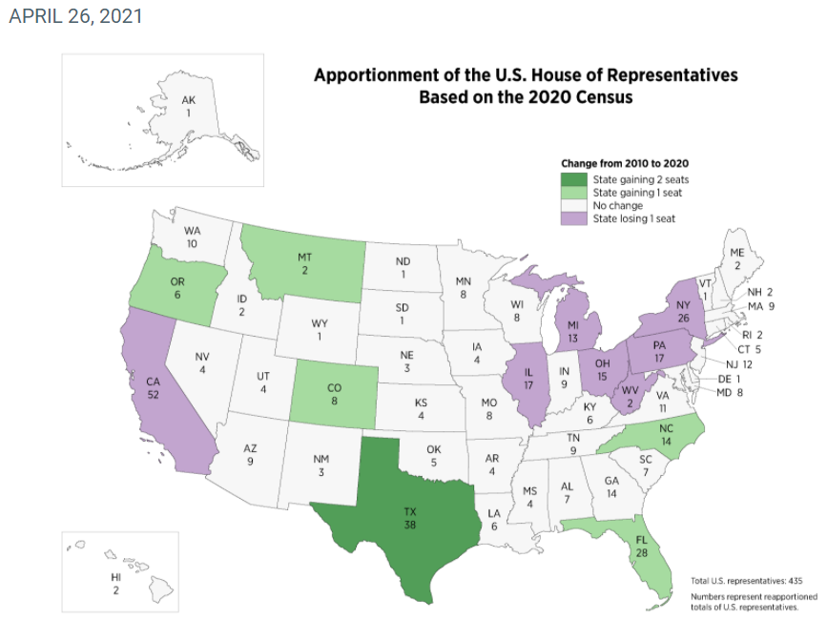
When analyzing each group of apportionment data, a histogram will be used to see when an expected change might occur. Each state’s expected change can be seen in the movement of the histogram. The creation of a prediction for each of the states will require an evaluation of each state’s indicators. These images will be used to show the indication of a near change.
Recommendations
The act of predicting apportionment for state is not based on past data. The knowledge needed to predict future apportionment numbers comes from closely monitoring the changes occurring in states regarding population over shorter periods of time. A decade is too long a period to use for the prediction.
Conclusion
The ability to predict when the apportionment for a state may change is an asset. When developing plans, states are benefited by the knowledge that can come from predicting when change might occur and the census data representing the change in population that has happened over the past decade is not the best tool for making this determination. When information from each decade is compiled to see if the data predicts the next change, it does not. (Rainhoa, 2016) To many events impact a state and the nation over a decade to provide a clear prediction of changes to apportionment. States should look to more current data throughout the decade to predict when changes may come to their state regarding apportionment to the US House of Representatives.

References:
Nelson, K. (2015). Business Intelligence, Strategies and Ethics. Nova Science Publishers, Inc., 2, 23-29.
Rajnoha, R., Stefko, R., Merková, M., & Dobrovic, J. (2016). Business intelligence as a key information and knowledge tool for strategic business performance management. E+M Ekonomie a Management, 19(1), 183–203
SAS Institute, Inc. (2016). Data mining from A to Z: How to discover insights and drive better opportunities [White paper].
Sharda, R., Delen, D., & Turban, E. (2017). Business intelligence, analytics, and data science: A managerial perspective (4th ed.). Pearson.

